 | Filing Reference : |  | GG/COMS/TS.2/24
 | Document Title : |  | Use-Case Realization Report (Analysis)  View Error
 | Version : |  | 1.0
 | Prepared By : |  | Koh Ming Jin
 | Date Created : |  | Monday, Apr 29th, 2011
Approved By :
 |  | Tran Ba Tien |  | Date
 |  | Project Manager |  | 29th Apr 2011
©2011 [Hoang Kim joint stock Company].
The information contained in this document is the property of [Hoang Kim joint stock Company]. The contents must not be reproduced, wholly or in part, for purposes other than for which it has been supplied, without the prior permission of [Hoang Kim joint stock Company], or, if it has been furnished under contract to another party, as expressly authorised under that contract. [Hoang Kim joint stock Company] shall not be liable for any errors or omissions.

Revision History
Date | Version | Description | Author
29/Apr/2011 | 1.0 | Initial Document | Koh Ming Jin

Table of Contents
1. Brief Description 4
2. Flow of Events 4
2.1 Standard Flow 4
2.1.1 Log-In 4
2.1.2 User Functions 4
2.1.3 Log-Out 4
2.2 Exception 4
3. Interaction Diagrams 5
3.1 Collaboration Diagram for View Error 5
4. Participating Objects 5
4.1 Main Page 5
4.2 Role Main Page 5
4.3 Main Controller 5
4.4 Error Controller 5
4.5 Error 5
5. Class Diagrams 6
5.1 Domain Class Diagram: View Error 6
6. Derived Requirements 6

Use-Case Realization Report
View Error

Brief Description
This use case enables an operation manager to view an error record.

Flow of Events
The standard flow of events for this use case and any exceptions are described in the following subsections. See section 3.1 for an overview of the participating Actors and Domain Objects.

Standard Flow
The flow of events is described as follows:

Log-In
To commence using the system, the Operation Manager is required to log-in successfully as follows:
- Refer to Log In Use Case for details.

User Functions
- The use case starts when Operation Manager selects the View Error option (operation initiate of MainPage) of the system. This will redirect to the RoleMainPage.

- To get the error list, the following will be performed:
  - Operation viewError (MainController) will be used to retrieve all the error details by calling the operation retrieveAllErrors of object Error Controller.
  - Employee Controller will return the error objects (using operations getErrorDetails & retrieveAllErrors).
  - The list of errors will be shown in the viewErrorPage (i.e. operation show)
- The View Error Page, which includes the error list, is displayed.

- The Operation Manager can click on a particular error (operation viewAParticularError) to view more details about the selected error.

- To get the selected employee details, the following will be performed:
  - View Employee Information Page will call the operation retrieveError of ErrorController
  - ErrorController will retrieve the selected Errorobject (i.e. operation: getErrorDetails)
  - ErrorController will return the information using the operation returnErrorDetails.

- The selected error details will be shown in the View Error Page

Log-Out
- The Operation Manager will terminate use of COMS (ie: log-out) by pressing a button with the caption “Log Out”.
- Refer to the Log Out Use Case for details.

Exception
- If the system is not able to retrieve the error details, an error message will be displayed. This will instruct the actor to inform the administrator.

Interaction Diagrams

Collaboration Diagram for View Error

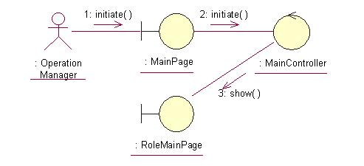
The above collaboration diagram shows the process flow after the actor has login.

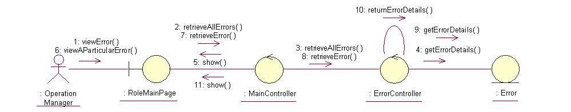
The above collaboration diagram shows the main process flow of this use case.

Participating Objects

Main Page
This object renders the contents after the actor has login. The Director, Department Manager and Operation Manager actors use this object.

Role Main Page
This object renders the contents to allow authorized actors to stop the cylinder production request. The Director, Department Manager and Operation Manager actors use this object.

Main Controller
This object acts as the middleman between Main Page and the Error Controller. It will translate interactions with the view into actions to be performed by the Error Controller.

Error Controller
This object acts as the middleman between “View Error” Page and the Error object. It will translate interactions with the view into actions to be performed by the Error object.

Error
This object stores the details concerning the error of the COMS.

Class Diagrams

Domain Class Diagram: View Error
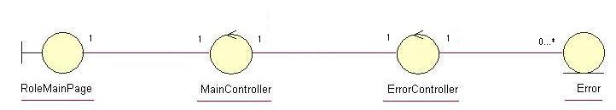

Derived Requirements
The Operation Manager PC keyboard and mouse will be used to retrieve error details (if any) and view all the system responses.

